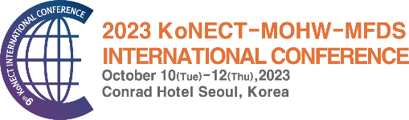 | 2023 KoNECT-MOHW-MFDS  INTERNATIONAL CONFERENCE

Application Form for Exhibition & Sponsorship

Please submit the Application Form by E-mail info-kic@konect.or.kr.
For further details, please contact the Exhibition Secretariat.

Applicant Information
Company Information
Company Name (ENGLISH): | Company Name (KOREAN):
Address:
Country: | Zip Code:
Contact Person’s Name: | Position:
Department: | Telephone:
Fax.: | Mobile Phone:
E-mail: | Website:
Exhibition Item(s): | Business Registration Number:

Category | Price(KRW)
 | Early Bird (~2023.6.30) | Standard (2023.7.1~9.8)
On-site Exhibition (Regular Booth) | □ 5,000,000(USD 4,200) x 1 (unit) | □ 5,500,000(USD 4,600) x 1 (unit)
 | □ 5,000,000(USD 4,200) x 2 (unit) | □ 5,500,000(USD 4,600) x 2 (unit)
On-site Exhibition (Special Booth) | Special Booth is included in Diamond Sponsorship.  - 6,000,000 (USD 5,000)
Total Fee (KRW)
Exhibition Booth

Booth Preferences: Booths are assigned on a first-come, first-serve basis. You will be able to select your booth once 2023 KIC floor plan is completed. Floor Plan will be confirmed after June.

Sponsorship Option
Category |  | Price(KRW)
Sponsorship  Package | □ Diamond Sponsor | 28,000,000 (USD 22,600)
 | □ Gold Sponsor | 18,000,000 (USD 14,600)
 | □ Silver Sponsor | 15,000,000 (USD 12,200)
 | □ Bronze Sponsor | 10,000,000 (USD 8,200)
Individual  Advertising | □ Logo on KIC newsletter | 3,000,000(USD 2,600)
 | □ Logo on KIC website | 2,000,000(USD 1,800)
 | □ Logo on photo wall | 2,000,000(USD 1,800)
 | □ Logo on event banner | 2,000,000(USD 1,800)
 | □ Full page Ad in program book | 1,000,000(USD 1,000)
 | Sponsor Session  (30 minutes presentation/Limit 9) | □ Exhibitor | 1,000,000(USD 1,000)
 |  | □ Non-Exhibitor | 2,000,000(USD 1,800)
Total Fee (KRW)

Date (DD/MM/YYYY ) COMPANY NAME (SIGNATURE)

